

**INTERNAL ASSIGNMENT**

**INTERNAL ASSIGNMENT**

**Course Code: OMC-307 July 23 Last Date of Submission: 31/12/24**

**Course Title: Design and Analysis of Algorithms Lab Maximum Marks: 30**

**Session: July 2024**

**Deepankar Sharma**

**233512013**

1. Write a C Program using recursive function to find the GCD of two numbers.

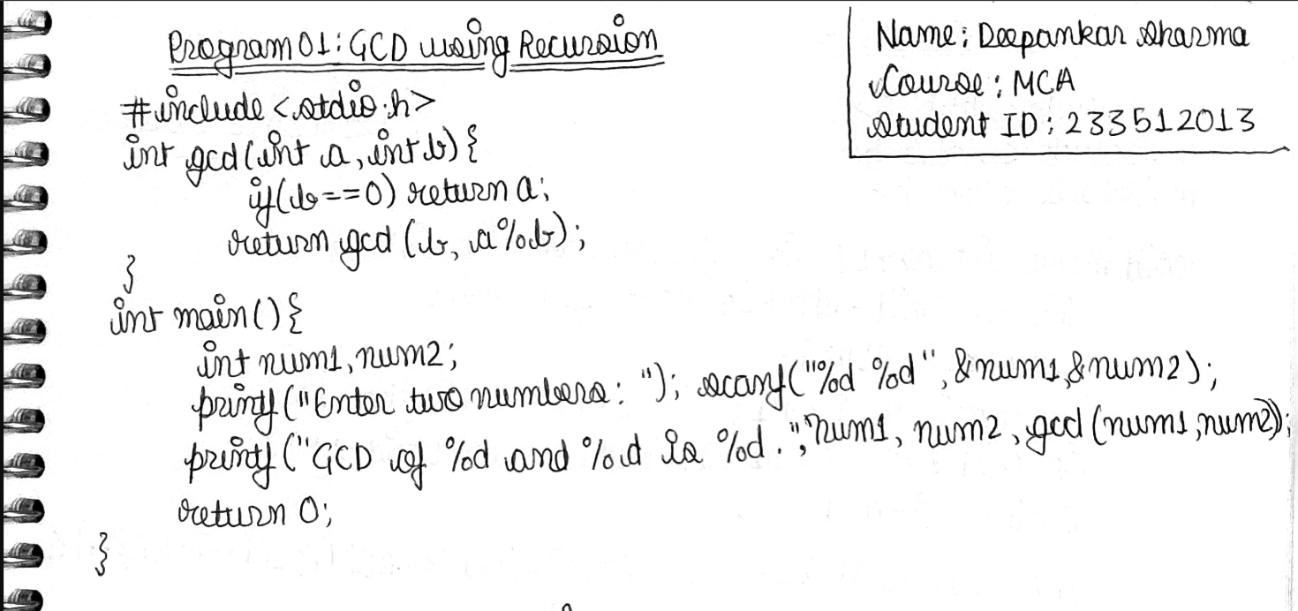

| **Output** |
| --- |
| image |
| image |
| image |

1. Write a C program using recursive function to implement towers of Hanoi problem.

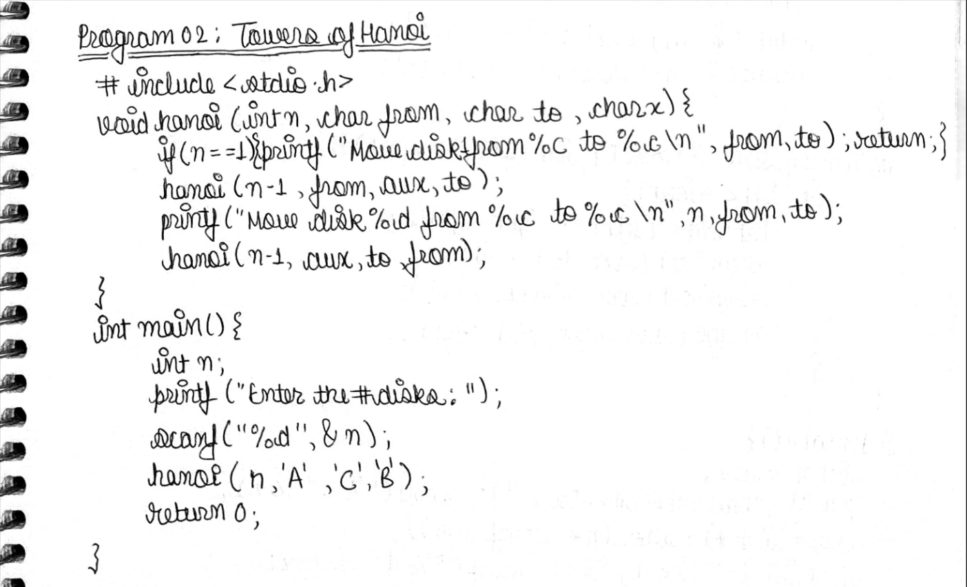

| **Output** |
| --- |
| image |
| image |
| image |

1. Sort a given set of numbers using the merge sort method and determine the time required to sort them.

| IMG_256 |
| --- |
| **Output** |
| image |
| image |
| image |

1. Sort a given set of numbers using the quick sort method and determine the time required to sort them.

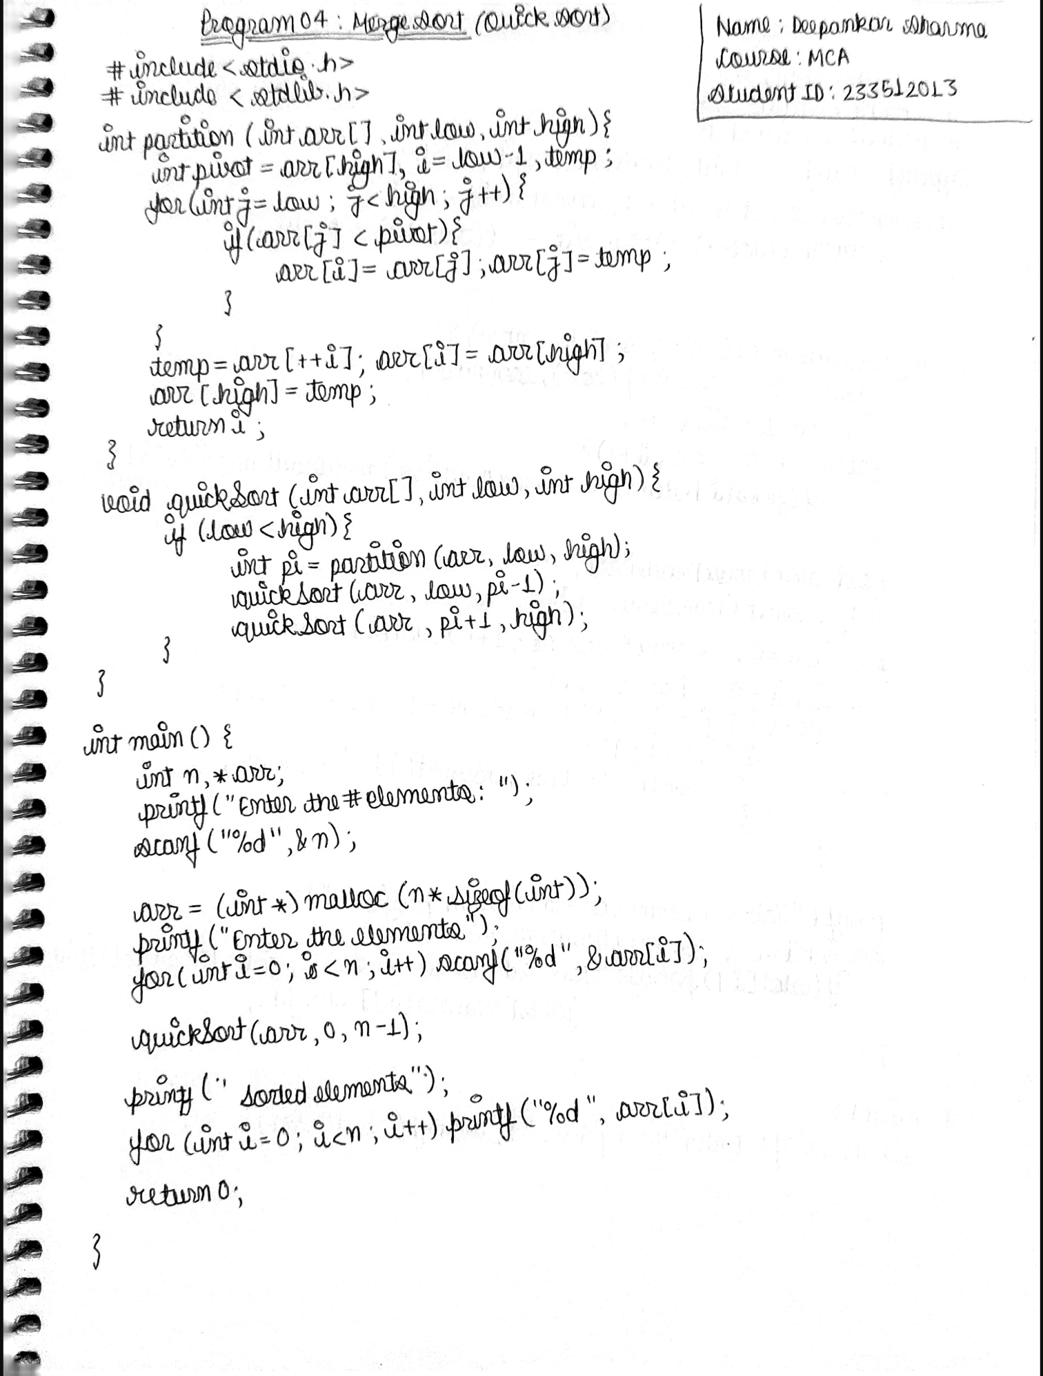

| **Output** |
| --- |
| image |
| image |
| image |

1. Given a set of n jobs, with (d\_i) and (p\_i) as deadline and profit for job i, write a program to find an optimal sequence of jobs, i.e., find the sequence of jobs that can be completed by their deadline and giving a maximum profit. Estimate the time complexity of the algorithm.

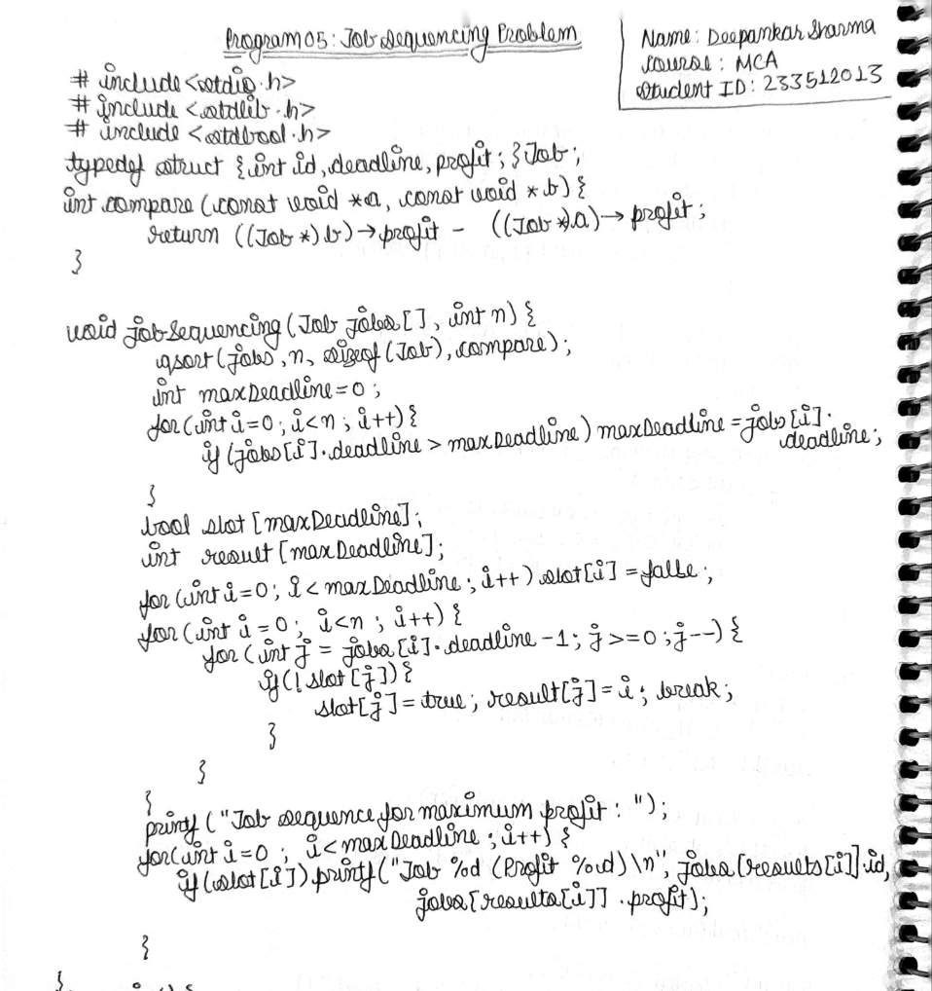

| **Output** |
| --- |
| image |
| image |
| image |

1. Write C programs to find the minimum cost spanning tree using Kruskal’s method.

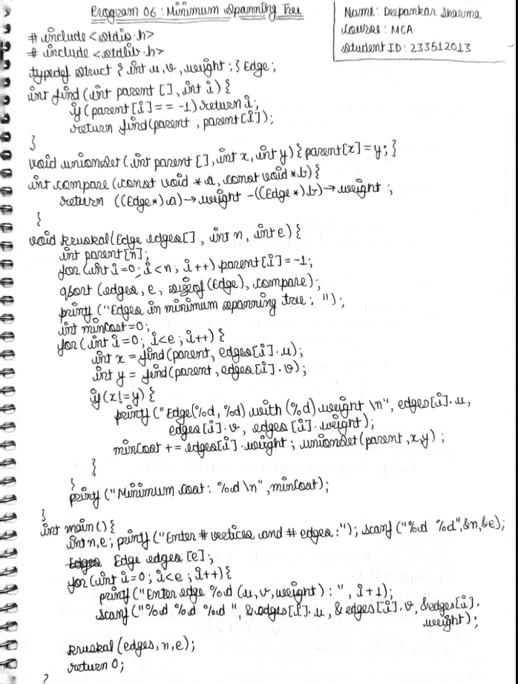

| **Output** |
| --- |
| image |
| image |
| image |

1. Write a C program to implement Dijkstra’s Algorithm to find the shortest paths from a given source vertex to all other vertices.

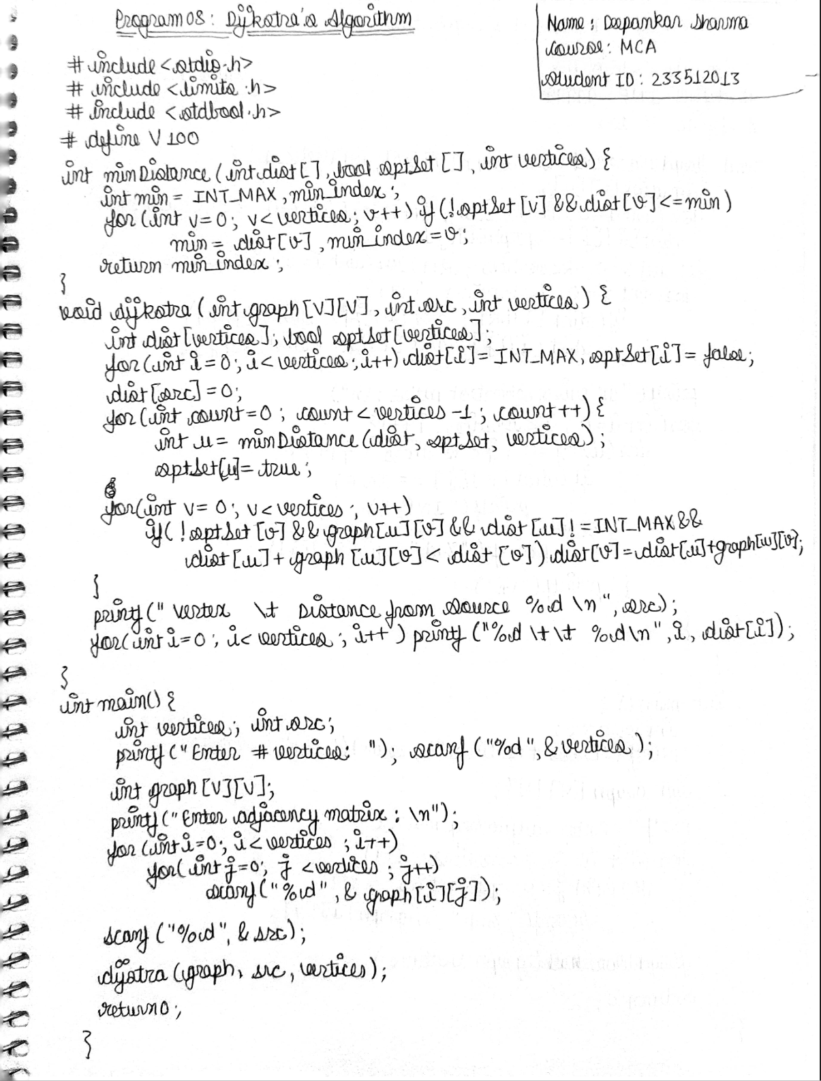

| **Output** |
| --- |
| image |
| image |
| image |

1. Write C program to find all pairs of shortest paths using Floyd’s algorithm.

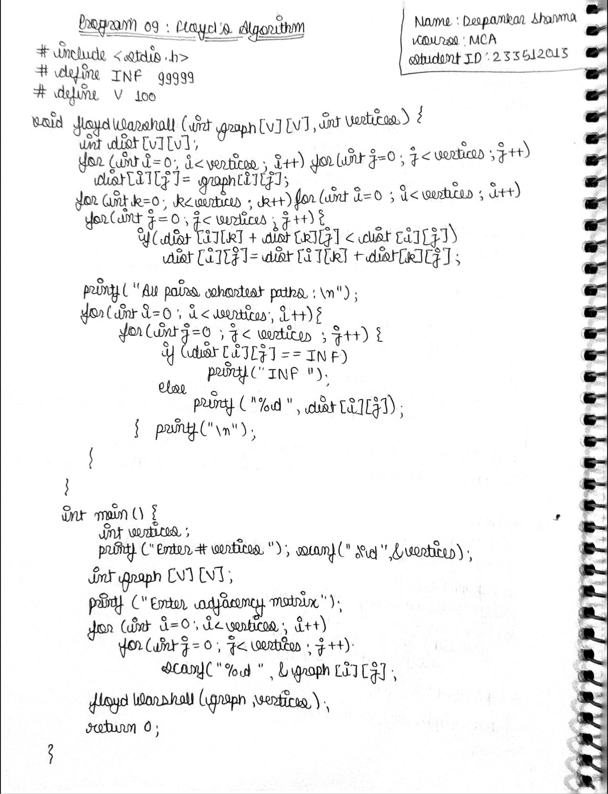

| **Output** |
| --- |
| image |
| image |
| image |

1. Write C program to implement 0/1 knapsack problem using dynamic programming.

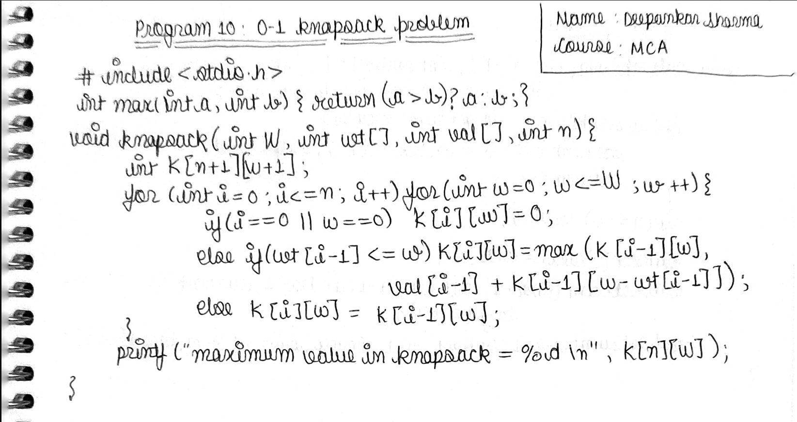

| **Output** |
| --- |
| image |
| image |
| image |

1. Write a C program to perform the following operations on a graph:
   * Depth First Search
   * Breadth First Search

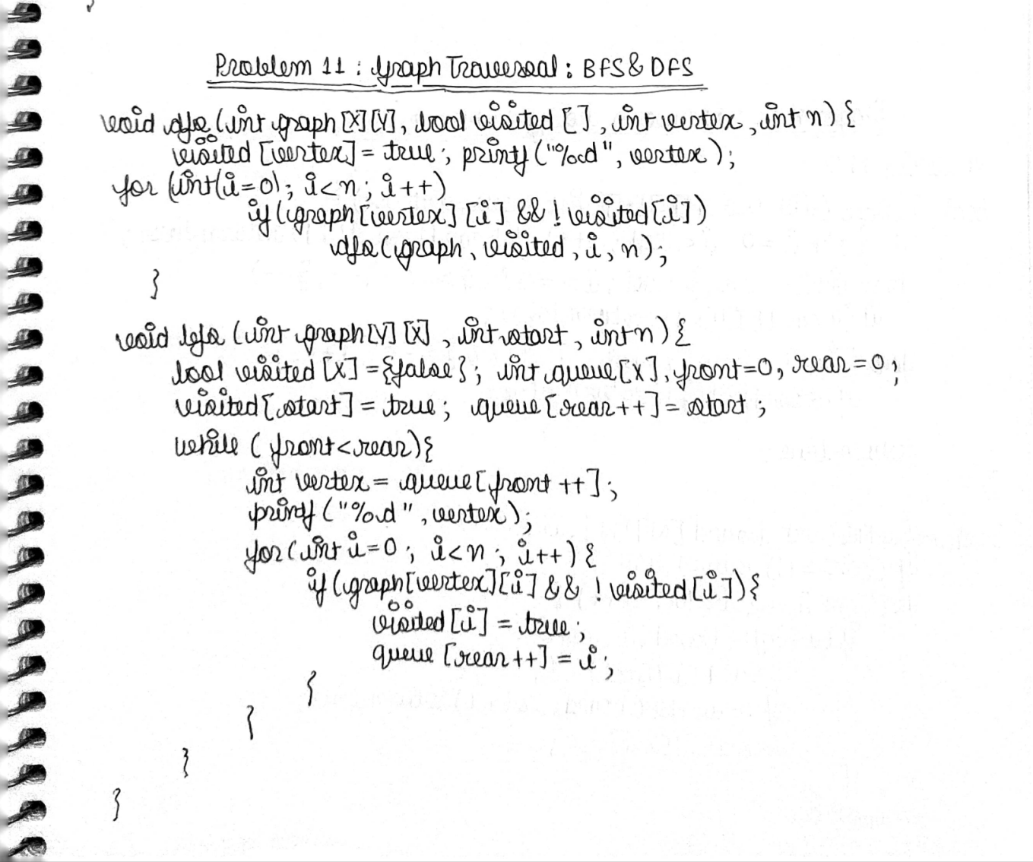

| **Output** |
| --- |
|  |
|  |
|  |

1. Write a C program to find a subset (S = {s\_1, s\_2, …., s\_m}) of a set (U) such that the sum of the elements of the subset (S) is equal to a given integer (d).

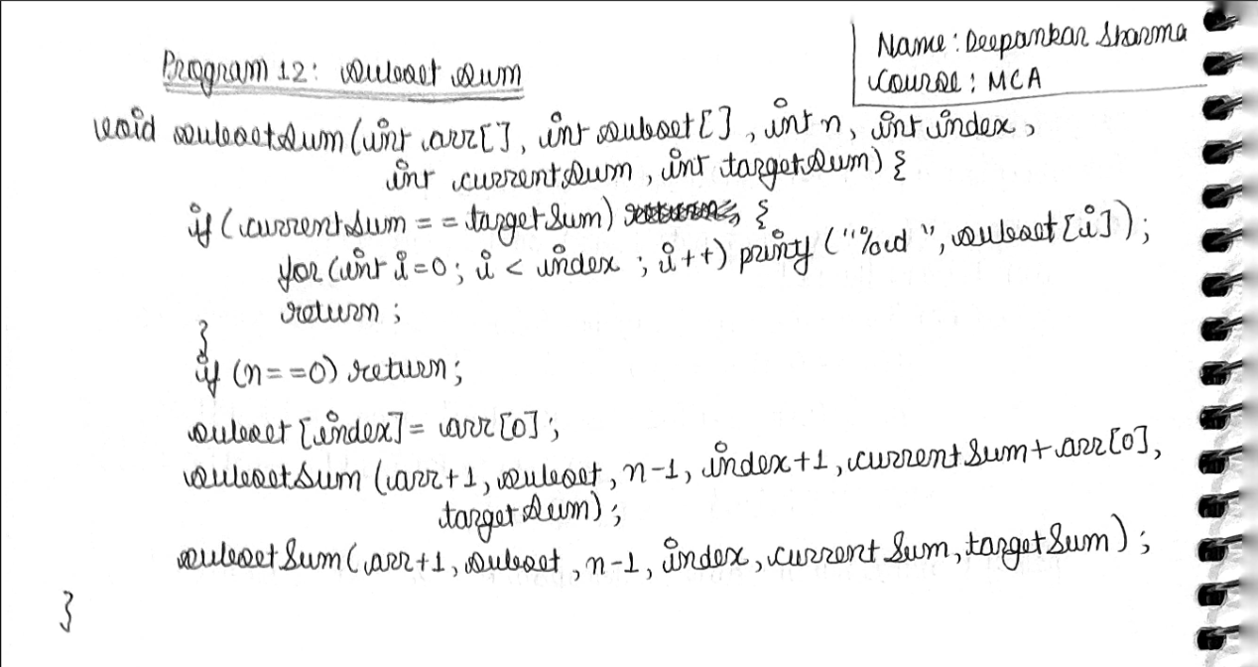

| **output** |
| --- |
| [IMG_256](https://private-user-images.githubusercontent.com/74599435/395573731-6d43a724-b4ad-440c-bc89-6fc38d6240d8.png?jwt=eyJhbGciOiJIUzI1NiIsInR5cCI6IkpXVCJ9..zuxkX8x08KOQIi1Nc6HQArQB_c3J-hmG950Jdf4wNO8) |
| [IMG_257](https://private-user-images.githubusercontent.com/74599435/395574037-e00beaa7-e3f9-43e0-84c7-a670764f4daf.png?jwt=eyJhbGciOiJIUzI1NiIsInR5cCI6IkpXVCJ9..ox4X4iR-7apmPxJ1WDLZFmb425lIhCNsErwSvtQoH-M) |
| [IMG_258](https://private-user-images.githubusercontent.com/74599435/395574268-e1a15ba5-0293-438d-91ce-475aa39dc86a.png?jwt=eyJhbGciOiJIUzI1NiIsInR5cCI6IkpXVCJ9..eY5kaDKTpY--x7LwtYDUbi5HrChAKtEDMVAoqzzaXUU) |

1. Write a C program to implement n-queen's problem using backtracking.

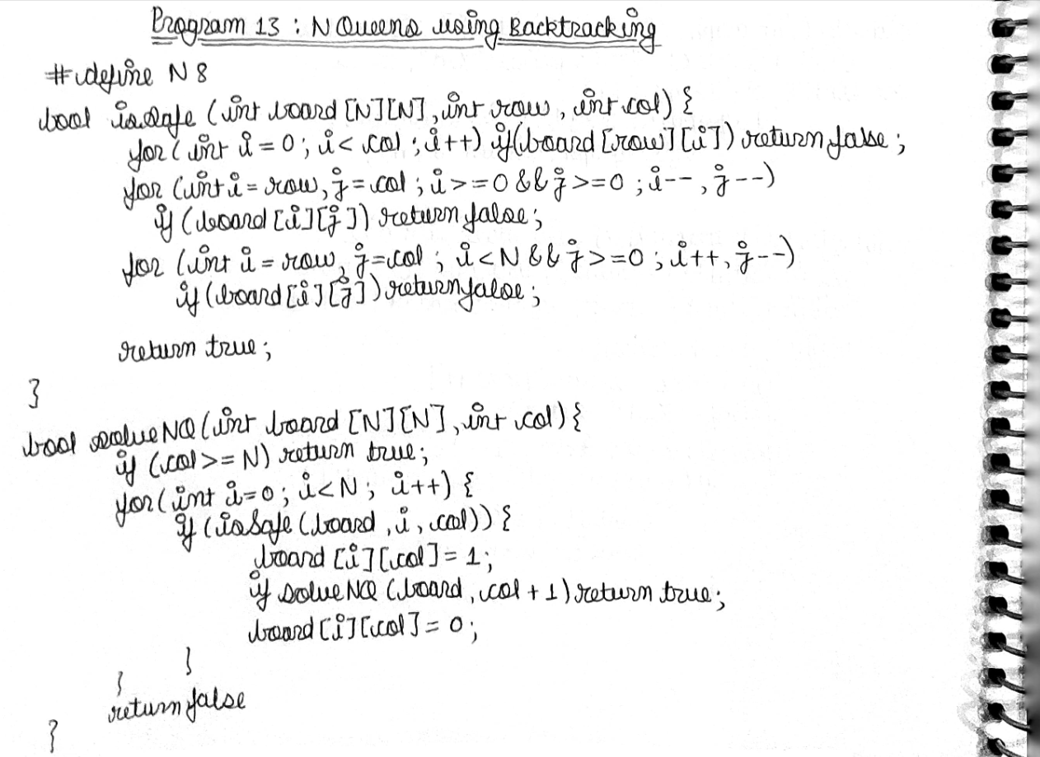

| **Output** |
| --- |
| image |
| image |
| image |